PYTHON ACTIVITY BASED LEARNING

Name: Anne Keerthana
Branch: CSE
Section: 01
Roll number: 26000006

CASE STUDY 8:Manufacturing Cost and Profitability Analysis

1. Problem Statement
To calculate the total manufacturing cost and profit from selling a product and determine whether the business earns a profit or a loss.
2. Objectives
- To calculate the total manufacturing cost.
- To calculate the selling amount.
- To determine the profit or loss.
3. Assumptions
- The user enters the material cost, labour cost, and selling amount.
- All amounts are non-negative.
- Total cost = Material cost + Labour cost.
- Profit = Selling amount − Total cost.
4. Algorithm
- Start.
- Input material cost.
- Input labour cost.
- Input selling amount.
- Calculate total cost.
- Calculate profit.
- If profit is positive, display profit.
- If profit is negative, display loss.
- Otherwise, display no profit and no loss.
10. Stop
5. Flowchart
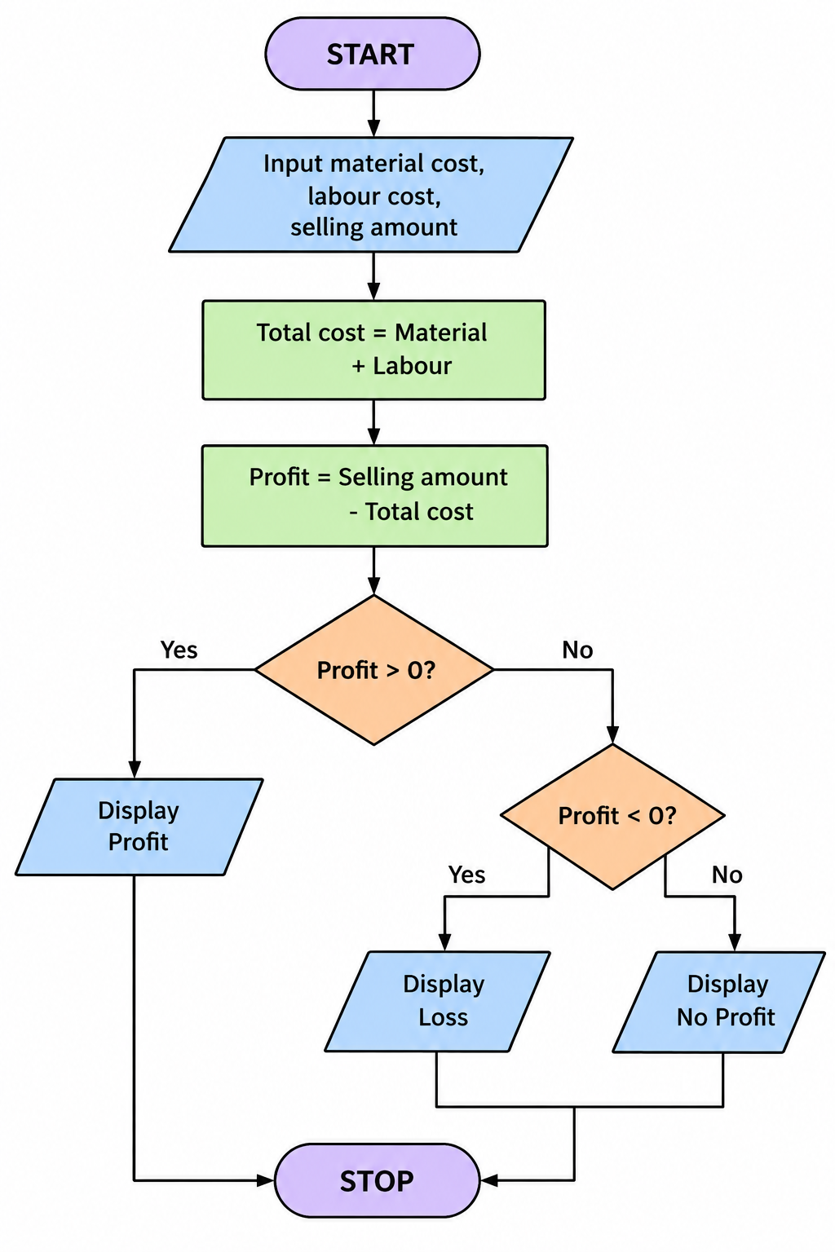

6.pseudocode
START
INPUT material_cost
INPUT labour_cost
INPUT selling_amount
total_cost = material_cost + labour_cost
profit = selling_amount - total_cost
IF profit > 0
PRINT profit
ELSE IF profit < 0
PRINT loss
ELSE
PRINT no profit and no loss
STOP

7. Python Source Code
material = int(input("Enter material cost: "))
labour = int(input("Enter labour cost: "))
selling = int(input("Enter selling amount: "))
cost = material + labour
profit = selling - cost
print("Total cost:", cost)
if profit > 0:
print("Profit:", profit)
elif profit < 0:
print("Loss:", -profit)
else:
print("No profit and no loss")

8. Test Cases
Venue | Food | Decoration | Sponsorship | Expected Result
2000 | 3000 | 1000 | 8000 | Surplus = 2000
2000 | 3000 | 1000 | 5000 | Shortage = 1000
2000 | 3000 | 1000 | 6000 | Expenses covered exactly
9.screenshots:
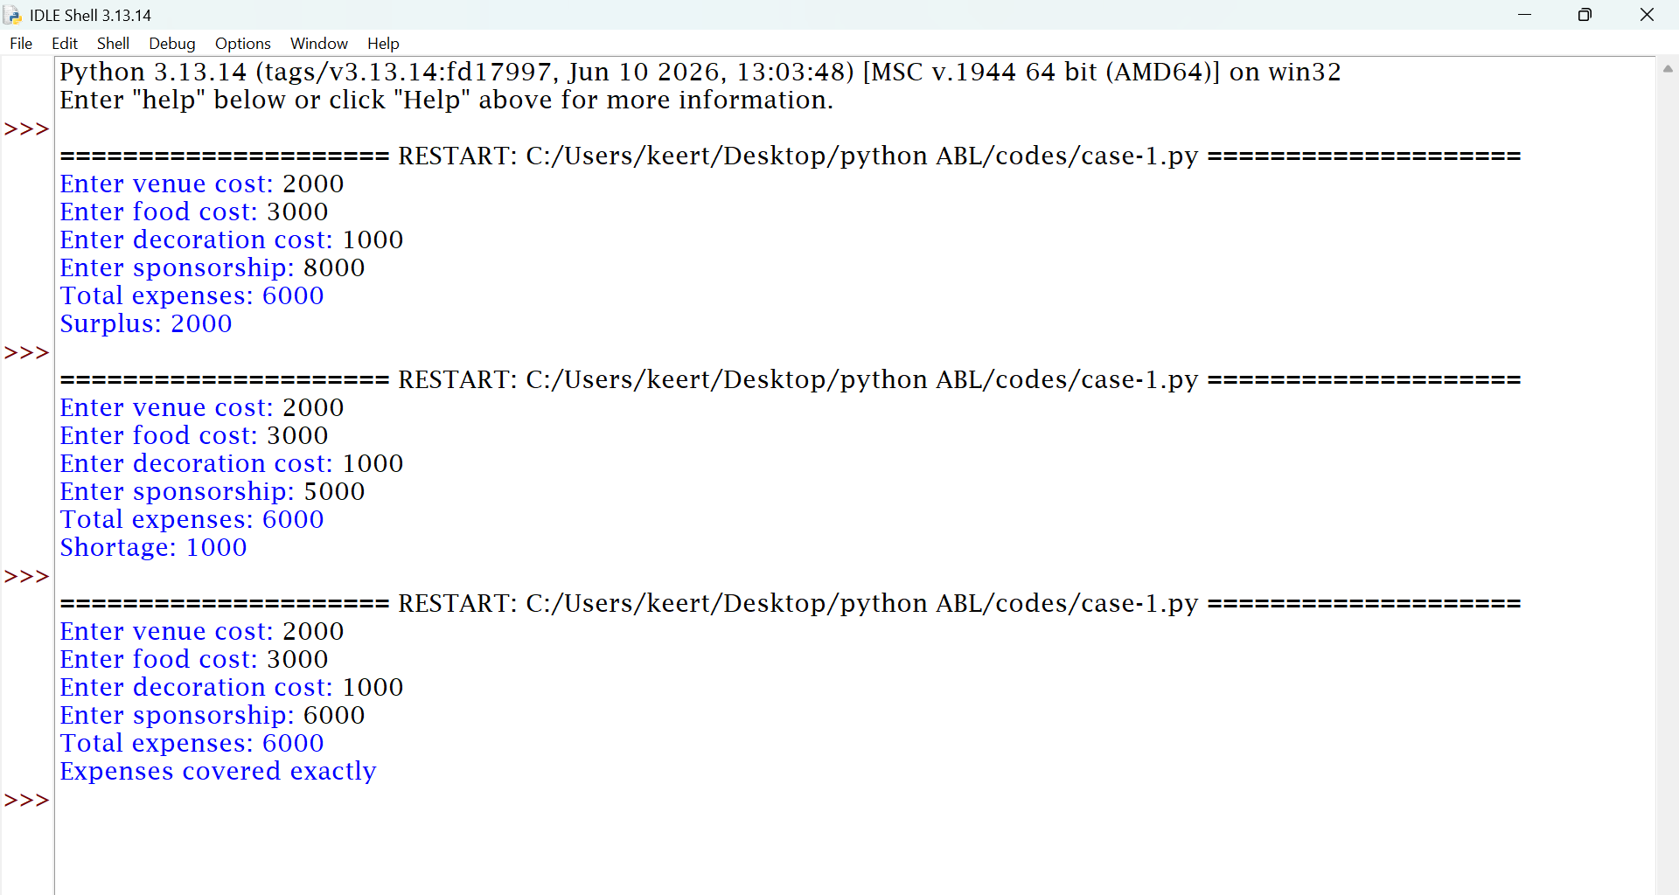

10. Conclusion
The program calculates college event expenses and determines whether the sponsorship is sufficient to cover them.

CASE STUDY 10: Campus Event Financial Planning

1. Problem Statement
To calculate the total expenses and remaining money for a college event using the event expenses and sponsorship amount.
2. Objectives
- To calculate the total event expenses.
- To compare expenses with sponsorship.
- To determine whether there is a surplus or shortage.
3. Assumptions
- The user enters venue, food, and decoration expenses.
- The user enters the sponsorship amount.
- All amounts are non-negative.
- Balance = Sponsorship − Total expenses.
4. Algorithm
- Start.
- Input venue expenses.
- Input food expenses.
- Input decoration expenses.
- Input sponsorship amount.
- Calculate total expenses.
- Calculate the balance.
- If the balance is positive, display the surplus.
- If negative, display the shortage.
10. Otherwise, display that the expenses are covered exactly
11.Stop
5. Flowchart
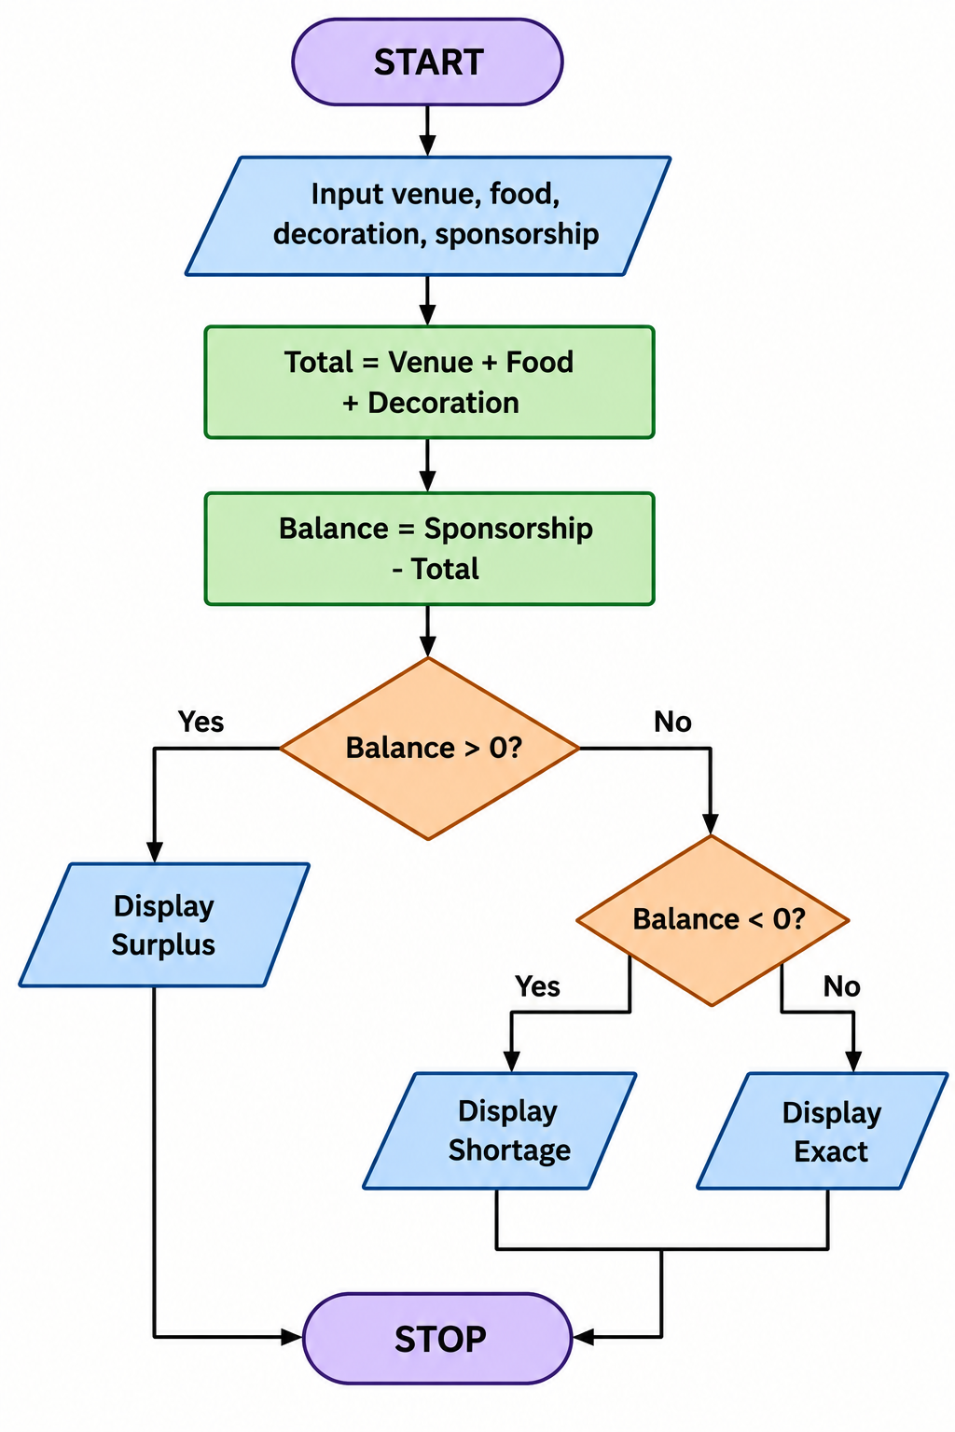

6. Pseudocode
START
INPUT venue
INPUT food
INPUT decoration
INPUT sponsorship
total = venue + food + decoration
balance = sponsorship - total
IF balance > 0
PRINT surplus
ELSE IF balance < 0
PRINT shortage
ELSE
PRINT expenses covered exactly
STOP

7. Python Source Code
venue = int(input("Enter venue cost: "))
food = int(input("Enter food cost: "))
decoration = int(input("Enter decoration cost: "))
sponsorship = int(input("Enter sponsorship: "))
total = venue + food + decoration
balance = sponsorship - total
print("Total expenses:", total)
if balance > 0:
print("Surplus:", balance)
elif balance < 0:
print("Shortage:", -balance)
else:
print("Expenses covered exactly")

8.Testcases
Venue | Food | Decoration | Sponsorship | Expected Result
2000 | 3000 | 1000 | 8000 | Surplus = 2000
2000 | 3000 | 1000 | 5000 | Shortage = 1000
2000 | 3000 | 1000 | 6000 | Expenses covered
exactly
9.screenshots
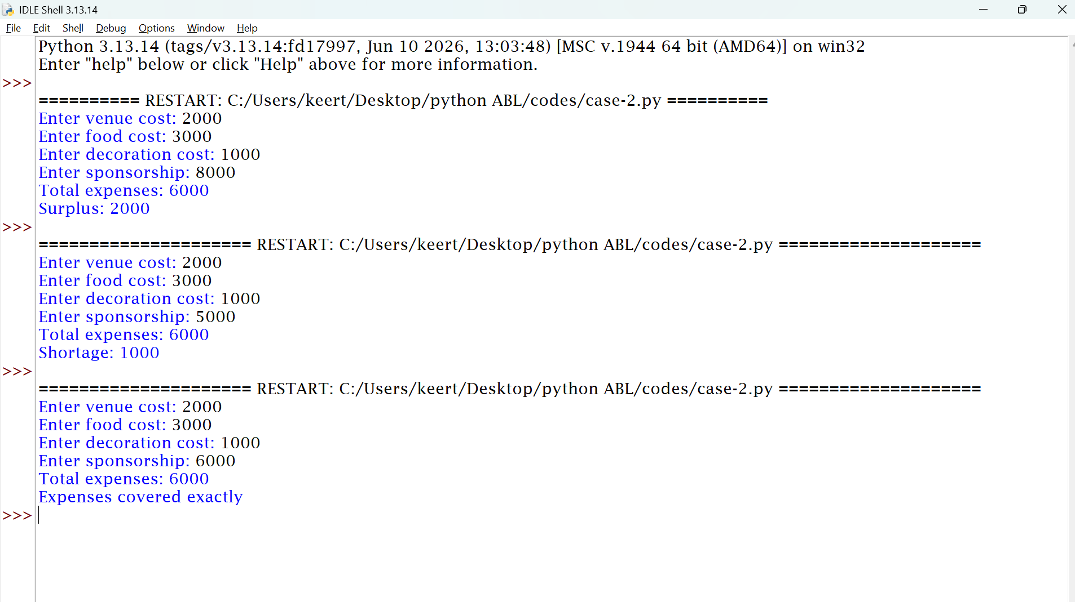
10. Conclusion
The program calculates college event expenses and determines whether the sponsorship is sufficient to cover them.

CASE STUDY 12: Attendance Recovery Computation
1. Problem Statement
To calculate a student's current attendance percentage and determine the minimum number of consecutive classes the student must attend to reach 75% attendance.
2. Objectives
- To calculate the current attendance percentage.
- To check whether attendance is at least 75%.
- To calculate the minimum additional classes required.
3. Assumptions
- The user enters total classes and attended classes.
- Total classes must be greater than zero.
- Attended classes cannot exceed total classes.
- Every future class is attended.
- The required attendance is 75%.
4. Algorithm
- Start.
- Input total classes.
- Input attended classes.
- Calculate attendance percentage.
- Display the percentage.
- If attendance is at least 75%, display eligible.
- Otherwise, use a while loop to calculate the additional classes needed.
- Display the required classes.
- Stop.

5. Flowchart
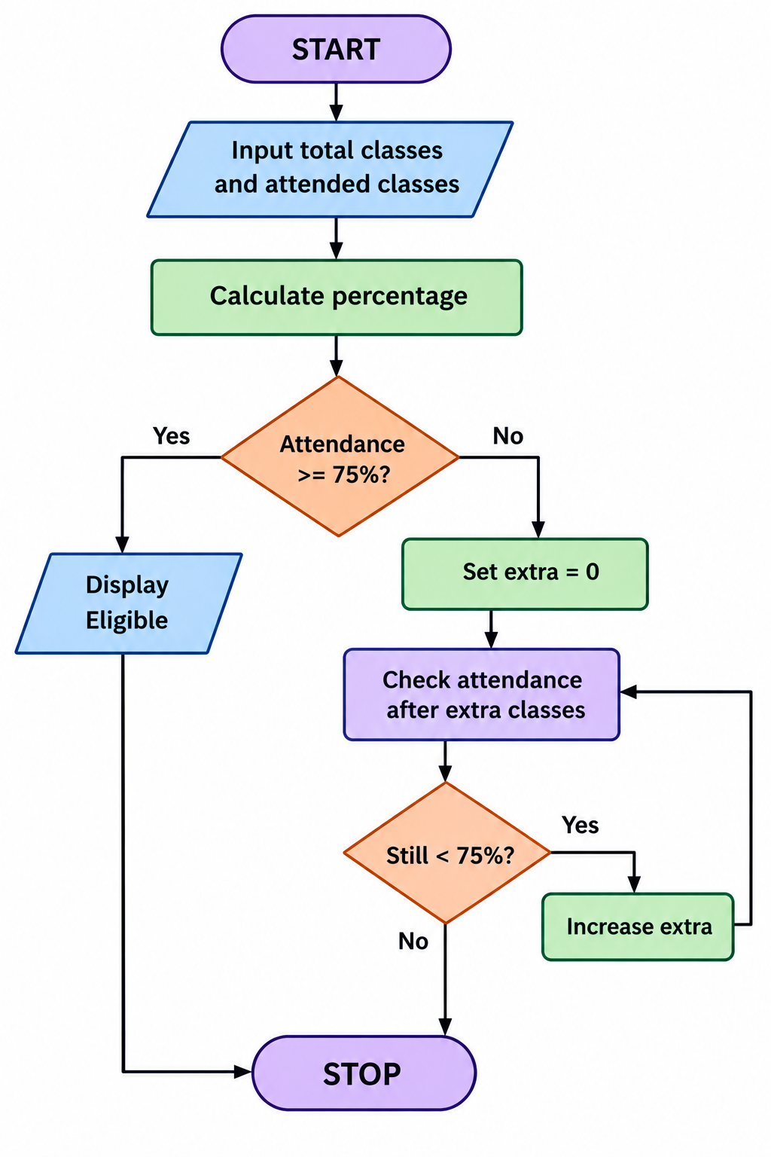

6. Pseudocode
START
INPUT total
INPUT attended
percentage = attended / total * 100
IF percentage >= 75
PRINT eligible
ELSE
extra = 0
WHILE (attended + extra) /
(total + extra) * 100 < 75
extra = extra + 1
PRINT extra
STOP

7. Python Source Code
total = int(input("Enter total classes: "))
attended = int(input("Enter attended classes: "))
percentage = attended / total * 100
print("Attendance:", percentage, "%")
if percentage >= 75:
print("Eligible")
else:
extra = 0
while (attended + extra) / (total + extra) * 100 < 75:
extra = extra + 1
print("Extra classes required:", extra)

8. Test Cases
Total Classes | Attended Classes | Attendance | Expected Result
100 | 80 | 80% | Already eligible
100 | 60 | 60% | 60 extra classes
100 | 75 | 75% | Already eligible
9.screenshots

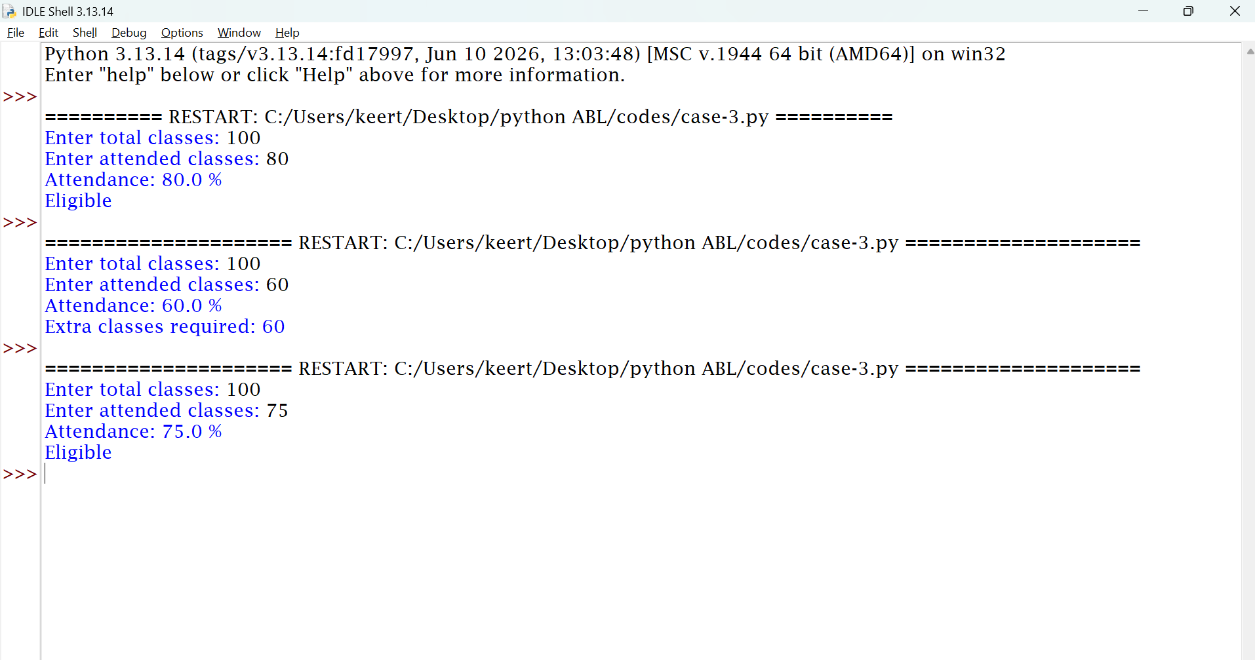

10. Conclusion
The program calculates attendance percentage and uses a while loop to determine the minimum additional classes needed to reach 75%.

CASE STUDY 13: ATM Transaction Sequence Simulation

1. Problem Statement
To simulate a simple ATM that allows a user to deposit money or withdraw money while maintaining the account balance.
2. Objectives
- To maintain the account balance.
- To process deposits and withdrawals.
- To prevent withdrawals exceeding the available balance.
3. Assumptions
- The initial balance is non-negative.
- Deposits must be positive.
- Withdrawals must be positive.
- A withdrawal cannot exceed the available balance.
- Only one transaction is performed in this simplified version.
4. Algorithm
- Start.
- Input the initial balance.
- Select deposit or withdrawal.
- Input the transaction amount.
- If depositing, add the amount to the balance.
- If withdrawing, check the available balance.
- Display the updated balance.
- Stop.

5. Flowchart
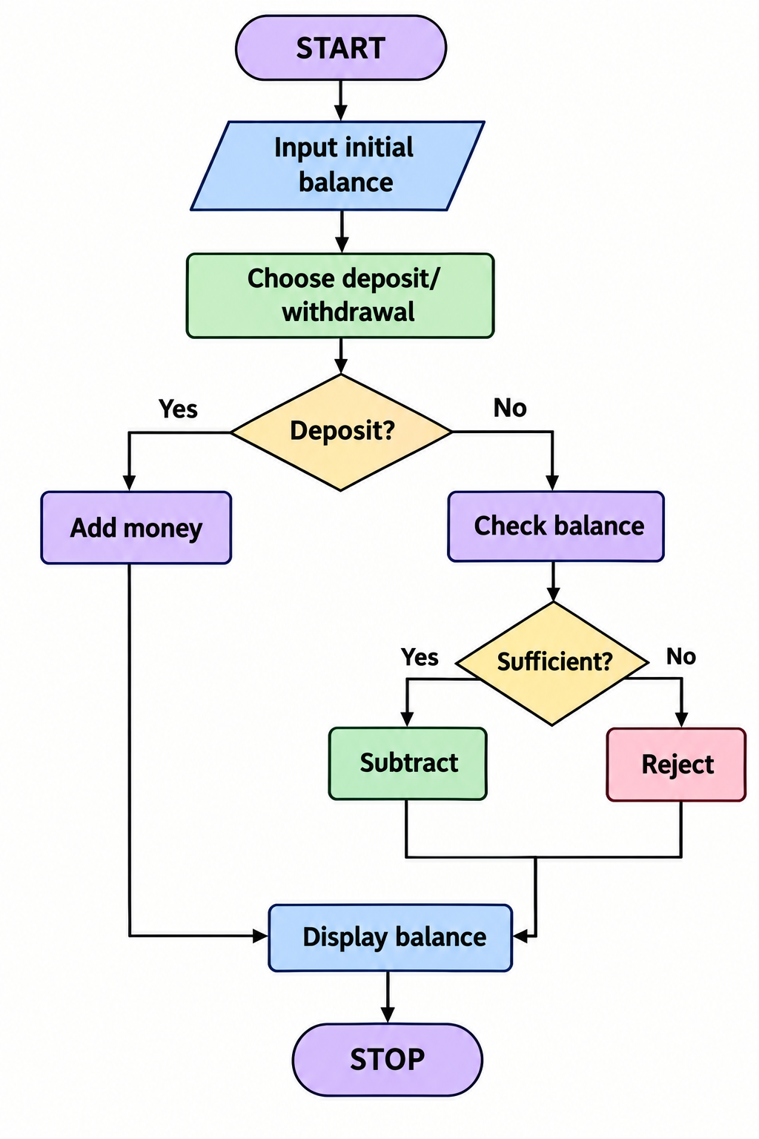

6. Pseudocode
START
INPUT balance
INPUT choice
INPUT amount
IF choice is deposit
balance = balance + amount
ELSE IF choice is withdrawal
IF amount <= balance
balance = balance - amount
ELSE
PRINT insufficient balance
PRINT balance
STOP

7. Python Source Code
balance = int(input("Enter initial balance: "))
print("1. Deposit")
print("2. Withdraw")
choice = int(input("Enter choice: "))
amount = int(input("Enter amount: "))
if amount <= 0:
print("Invalid amount")
elif choice == 1:
balance = balance + amount
print("Deposit successful")
elif choice == 2:
if amount <= balance:
balance = balance - amount
print("Withdrawal successful")
else:
print("Insufficient balance")
else:
print("Invalid choice")
print("Final balance:", balance)

8.Testcases
Intial balance choice amount expected result
1000 deposit 500 balance=1500
1000 withdraw 300 balance=700
1000 withdraw 1500 Insufficent
9.screenshots
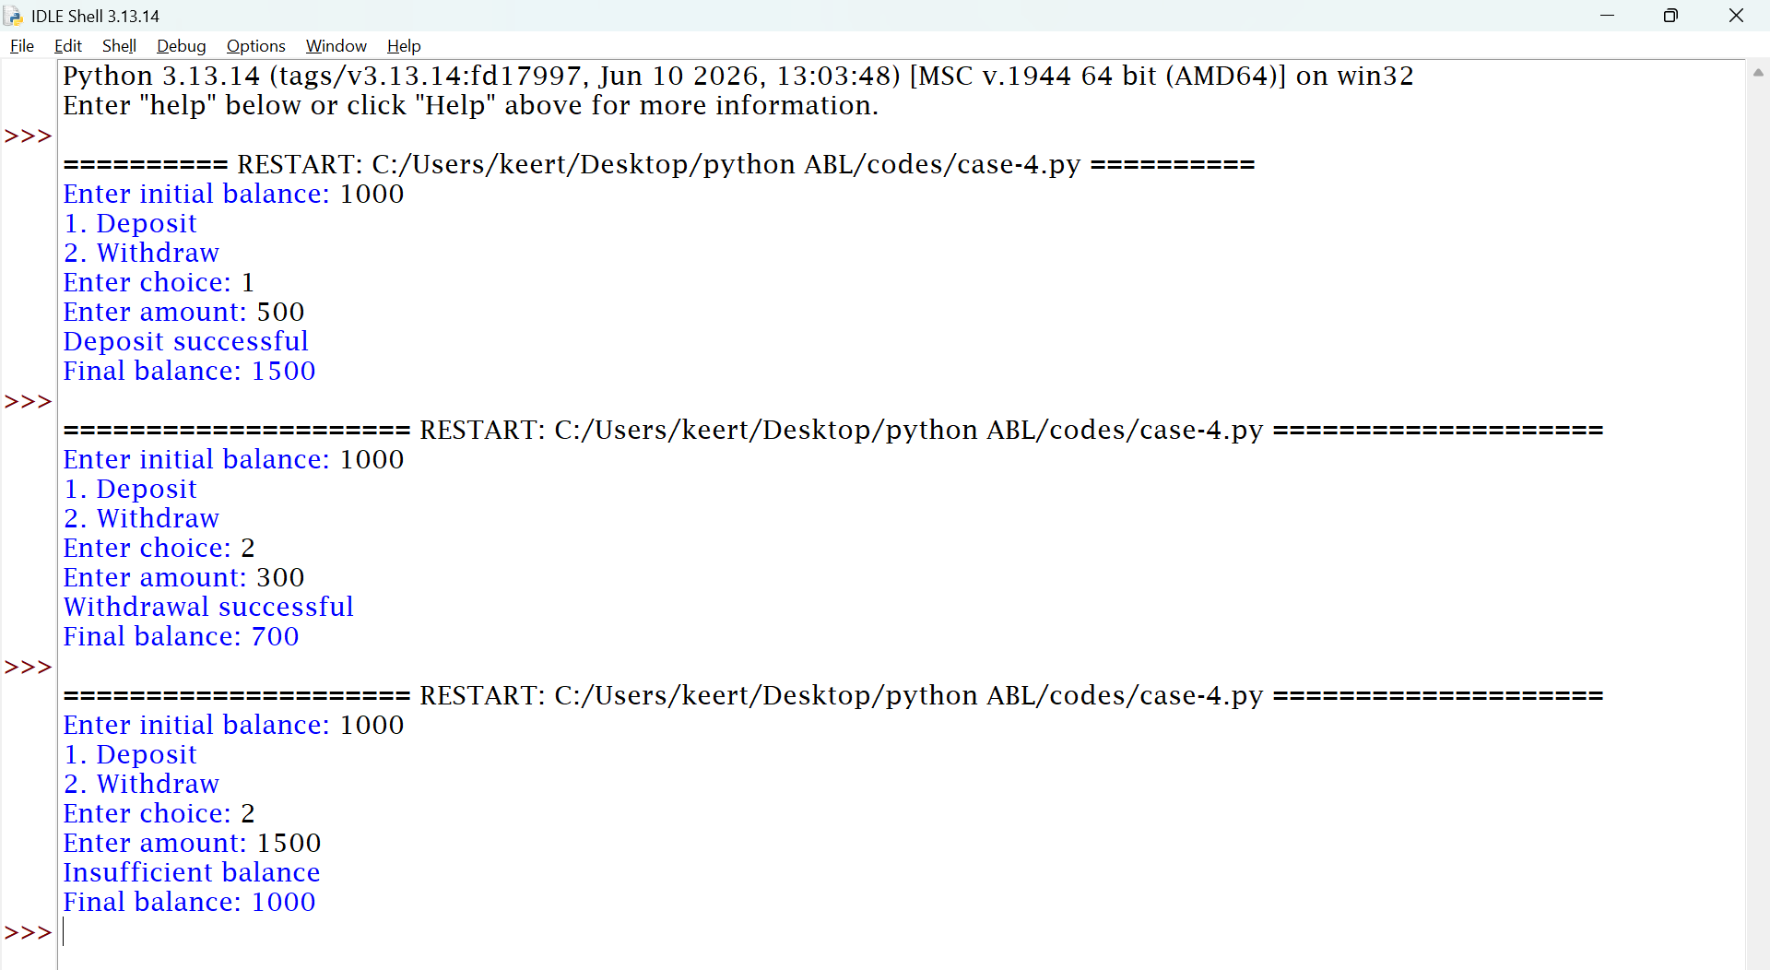
10.Conclusion
The program simulates basic ATM transactions and updates the account balance according to the selected operation

CASE STUDY 17: Student Performance Trend Analysis

1. Problem Statement
To compare a student's marks in two examinations and determine whether the student's performance has improved, decreased, or remained unchanged.
2. Objectives
- To accept marks from two examinations.
- To calculate the difference between marks.
- To identify the performance trend.
3. Assumptions
- Marks are between 0 and 100.
- The student takes two examinations.
- The difference is calculated as second examination marks minus first examination marks.
4. Algorithm
- Start.
- Input first examination marks.
- Input second examination marks.
- Calculate the difference.
- If the difference is positive, display improvement.
- If negative, display a decrease.
- Otherwise, display no change.
- Stop.

5. Flowchart
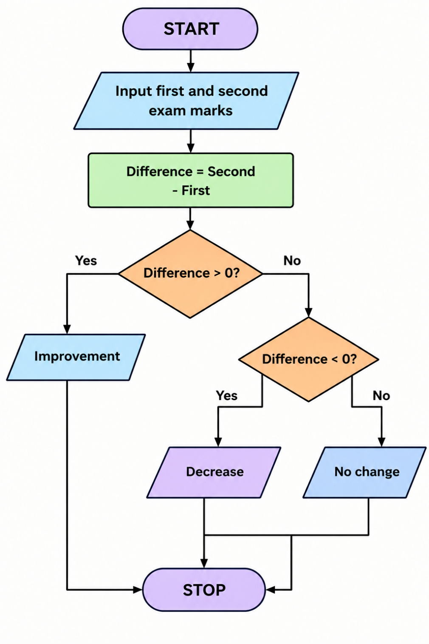

6. Pseudocode
START
INPUT first_marks
INPUT second_marks
difference = second_marks - first_marks
if difference > 0
PRINT improvement
else IF difference < 0
PRINT decrease
else
print no change
STOP

7. Python Source Code
first = int(input("Enter first exam marks: "))
second = int(input("Enter second exam marks: "))
difference = second - first
if difference > 0:
print("Marks improved by", difference)
elif difference < 0:
print("Marks decreased by", -difference)
else:
print("No change in marks")

8. Test Cases

First case second case expected result
60 80 improved by 20
80 60 improved by 20
75 75 improved by no
Change

9.screenshots
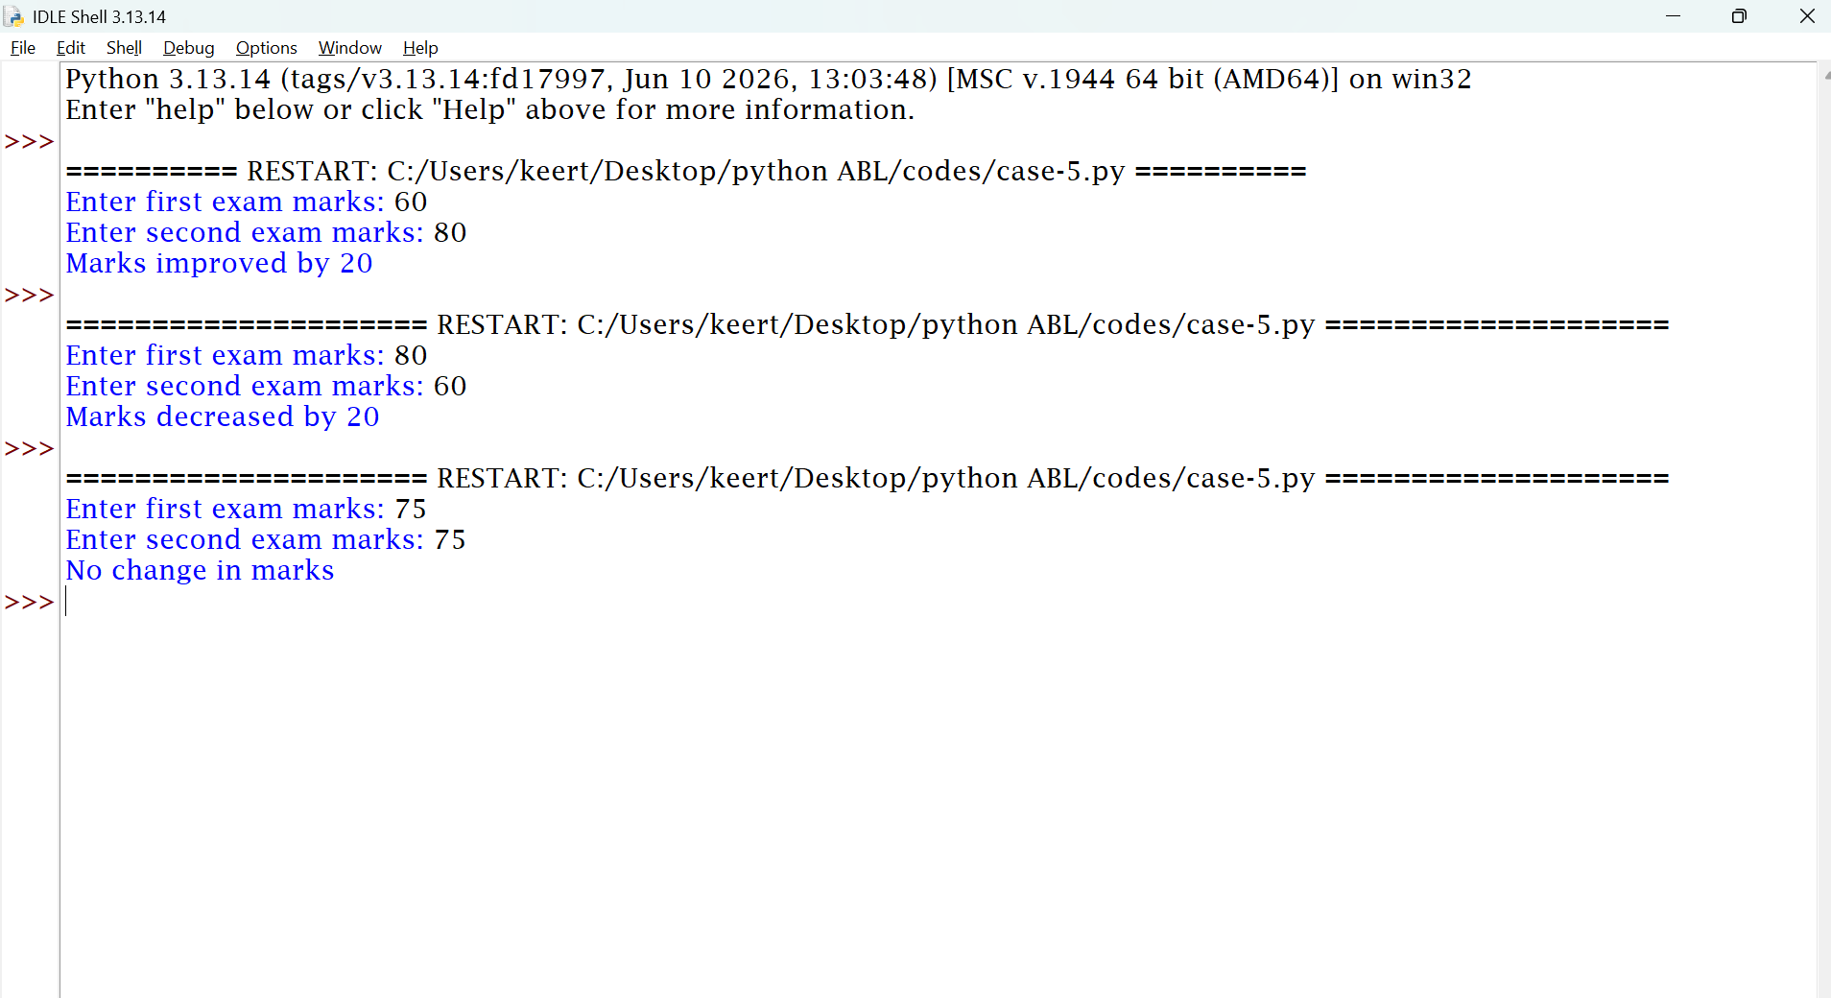

10. Conclusion
The program compares examination marks and identifies whether student performance has improved, decreased, or remained unchanged.

CASE STUDY 19: Multi-Product Shopping Budget Constraint

1. Problem Statement
To calculate the total shopping cost and determine whether the purchase fits within the available budget.
2. Objectives
- To calculate the total purchase cost.
- To compare the cost with the budget.
- To determine whether the budget is sufficient.
3. Assumptions
- The user enters the prices of two products and their quantities.
- The user enters the available budget.
- Prices, quantities, and budget are non-negative.
4. Algorithm
- Start.
- Input the price and quantity of the first product.
- Input the price and quantity of the second product.
- Input the budget.
- Calculate the total cost.
- If the cost is within the budget, display the remaining amount.
- Otherwise, display the additional amount required.
- Stop.

5. Flowchart
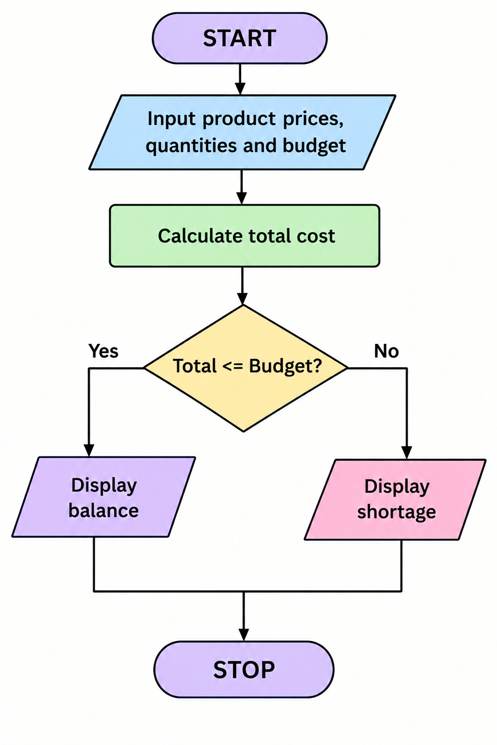

6. Pseudocode
START
INPUT price1, quantity1
INPUT price2, quantity2
INPUT budget
total = price1 * quantity1
+ price2 * quantity2
IF total <= budget
PRINT remaining budget
ELSE
PRINT extra money required
STOP

7. Python Source Code
p1 = int(input("Enter first product price: "))
q1 = int(input("Enter first product quantity: "))
p2 = int(input("Enter second product price: "))
q2 = int(input("Enter second product quantity: "))
budget = int(input("Enter budget: "))
total = p1 * q1 + p2 * q2
print("Total cost:", total)
if total <= budget:
print("Money remaining:", budget - total)
else:
print("Extra money needed:", total - budget)

8. Test Cases
Product 1 Price × Quantity | Product 2 Price × Quantity | Budget | Expected
100 × 2 | 200 × 1 | 500 | Remaining = 100
200 × 2 | 300 × 1 | 500 | Extra needed = 200
100 × 2 | 100 × 1 | 300 | Remaining = 0

9.screenshots
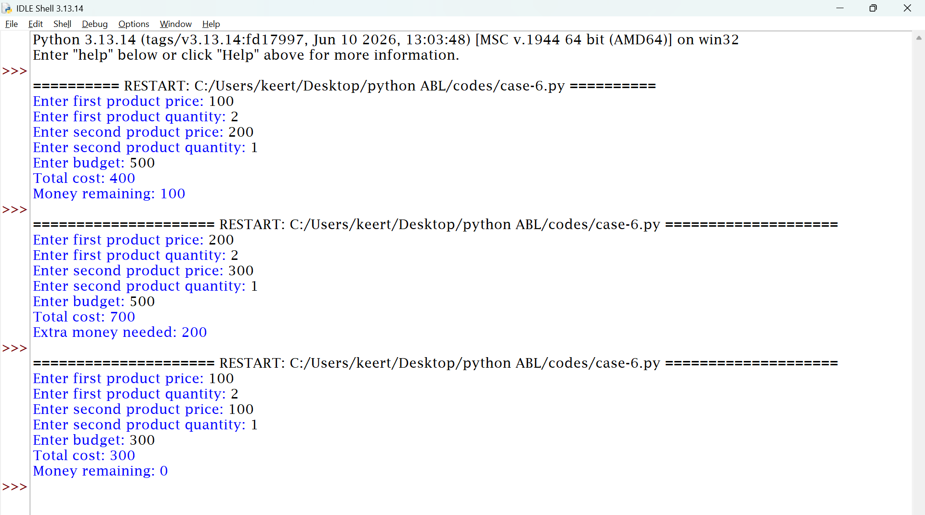

10. Conclusion
The program calculates shopping expenses and checks whether the purchase can be completed within the available budget.

CASE STUDY 21: Traffic Violation Penalty Calculator

1. Problem Statement
To calculate a traffic penalty based on the type of violation selected by the user.
2. Objectives
- To accept a traffic violation type.
- To assign a penalty based on the selected type.
- To display the applicable penalty.
3. Assumptions
For this simplified example, the following hypothetical penalties are used:
- No helmet: ₹500
- No seat belt: ₹500
- Over-speeding: ₹1000
- Other or invalid choice: No penalty assigned.
These amounts are illustrative values for a programming exercise, not a statement of current legal fines.
4. Algorithm
- Start.
- Display the violation options.
- Input the violation choice.
- If the choice is 1, assign ₹500.
- If the choice is 2, assign ₹500.
- If the choice is 3, assign ₹1000.
- Otherwise, display an invalid choice.
- Stop.
5. Flowchart
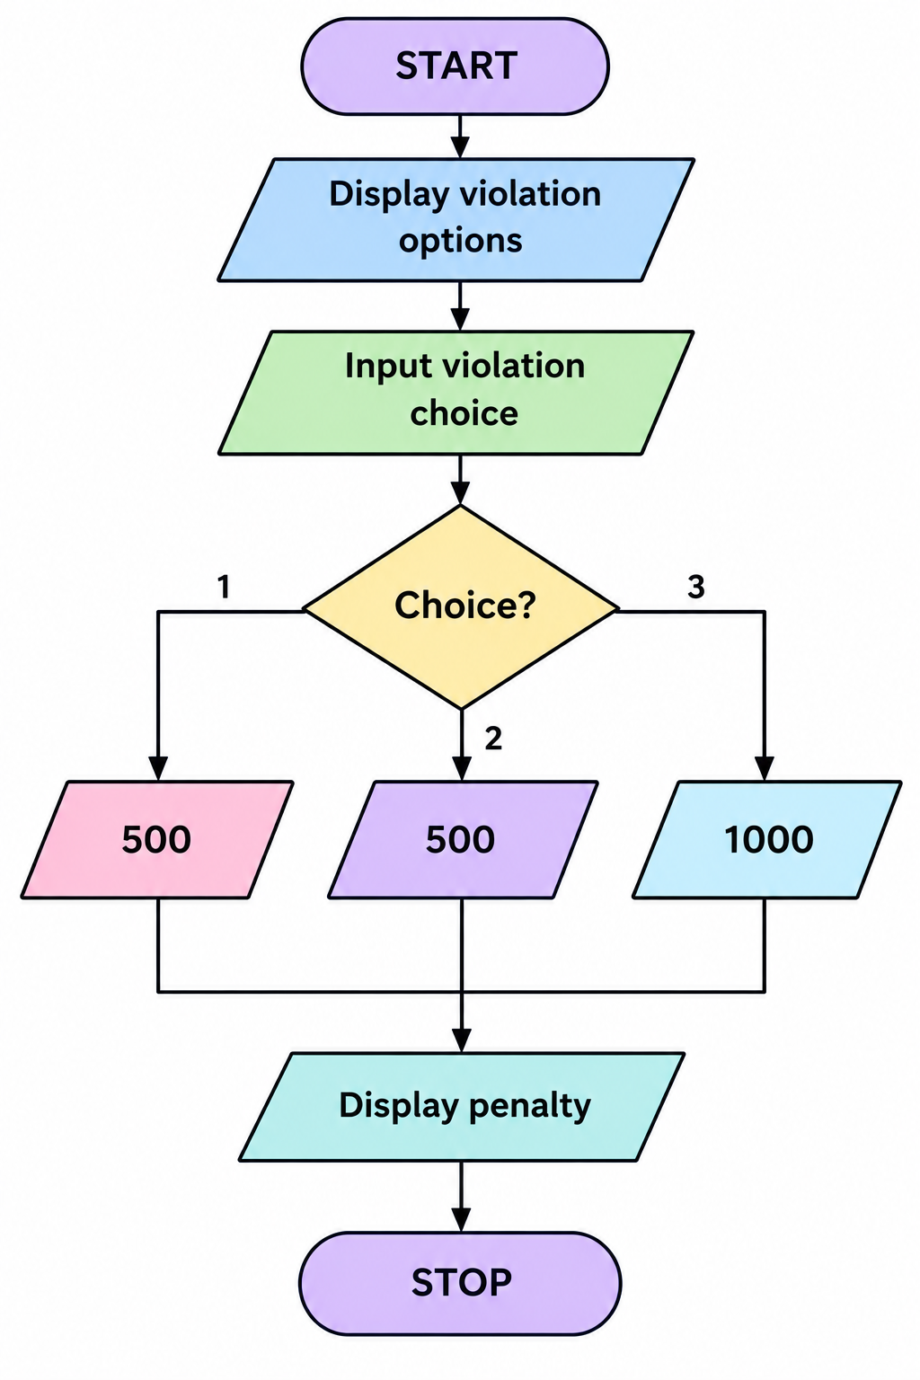

6. Pseudocode
START
DISPLAY violation options
INPUT choice
IF choice == 1
penalty = 500
ELSE IF choice == 2
penalty = 500
ELSE IF choice == 3
penalty = 1000
ELSE
PRINT invalid choice
IF choice is valid
PRINT penalty
STOP

7. Python Source Code
print("1. No helmet")
print("2. No seat belt")
print("3. Over-speeding")
choice = int(input("Enter choice: "))
if choice == 1:
print("Penalty: Rs.500")
elif choice == 2:
print("Penalty: Rs.500")
elif choice == 3:
print("Penalty: Rs.1000")
else:
print("Invalid choice")

8. Test Cases
Choice | Expected Result
1 | Penalty: ₹500
2 | Penalty: ₹500
3 | Penalty: ₹1000
4 | Invalid choice

9.Screenshots
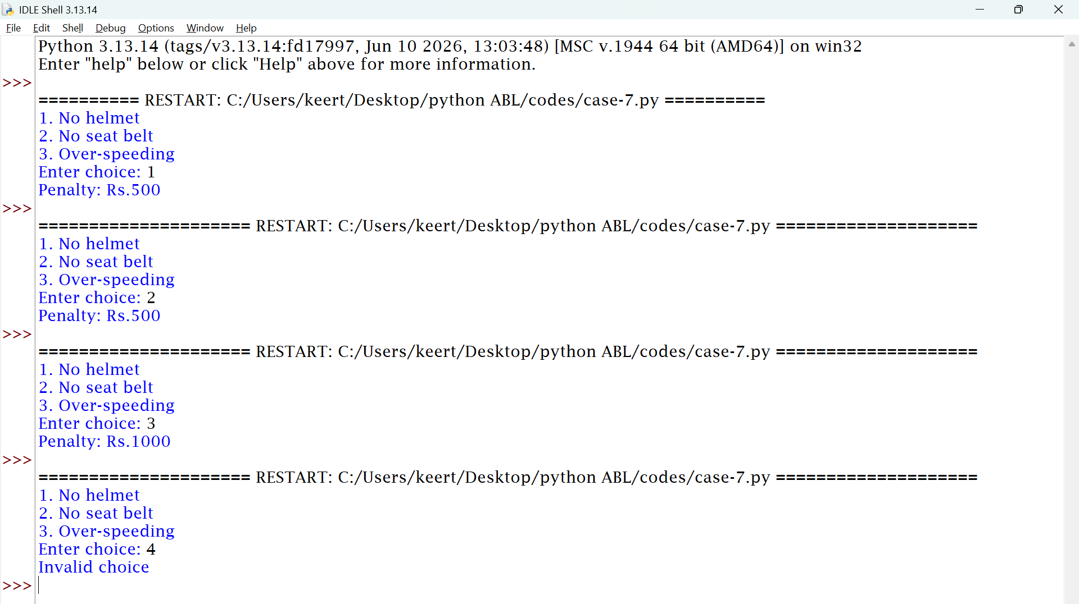

10. Conclusion
The program identifies a selected traffic violation and displays its assigned penalty.
CASE STUDY 29: Password Policy Validation Engine

1. Problem Statement
To check whether a password satisfies a basic password-length requirement.
2. Objectives
- To accept a password from the user.
- To check the password length.
- To display whether the password meets the requirement.
3. Assumptions
- The password must contain at least eight characters.
- The password is entered as text.
- This simplified program checks length only; it does not check uppercase letters, digits, or special characters.
4. Algorithm
- Start.
- Input a password.
- Calculate the password length.
- If the length is at least eight, display valid.
- Otherwise, display invalid.
- Stop.

5. Flowchart
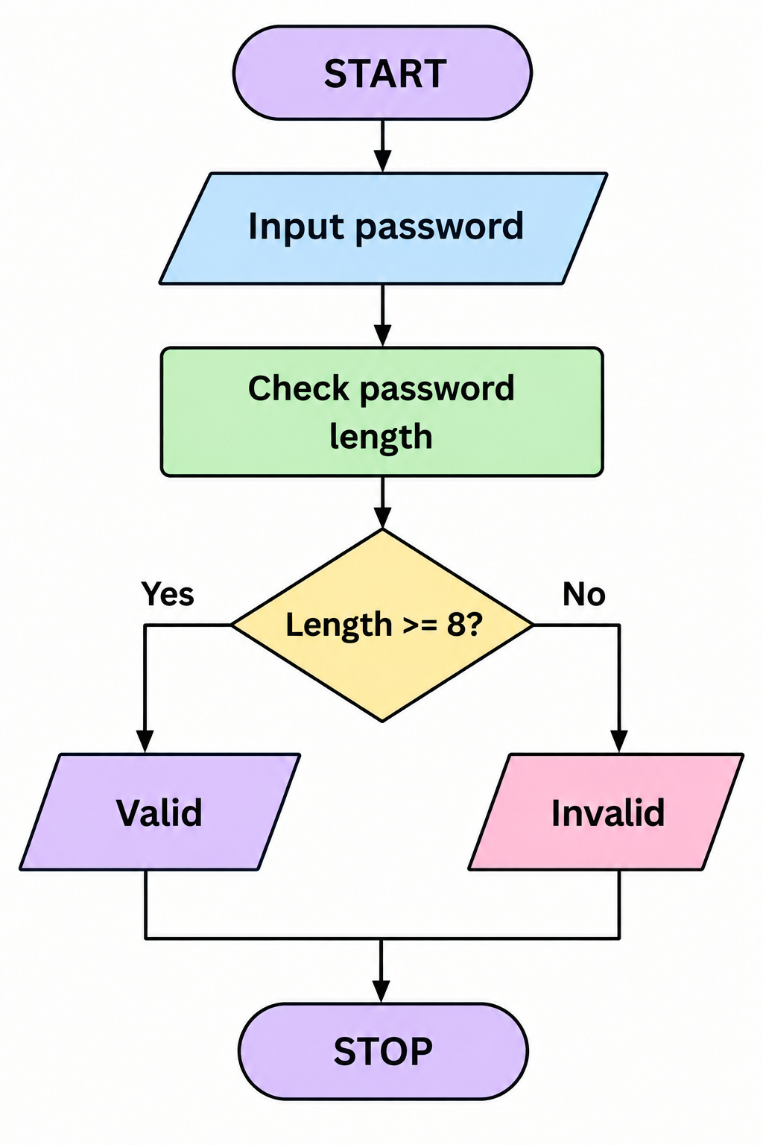

6. Pseudocode
START
INPUT password
IF length of password >= 8
PRINT valid password
ELSE
PRINT invalid password
STOP

7. Python Source Code
password = input("Enter password: ")
if len(password) >= 8:
print("Valid password")
else:
print("Invalid password")

8. Test Cases
Password | Length | Expected Result
hello | 5 | Invalid password
python123 | 9 | Valid password
abcdefgh | 8 | Valid password

9.Screenshots
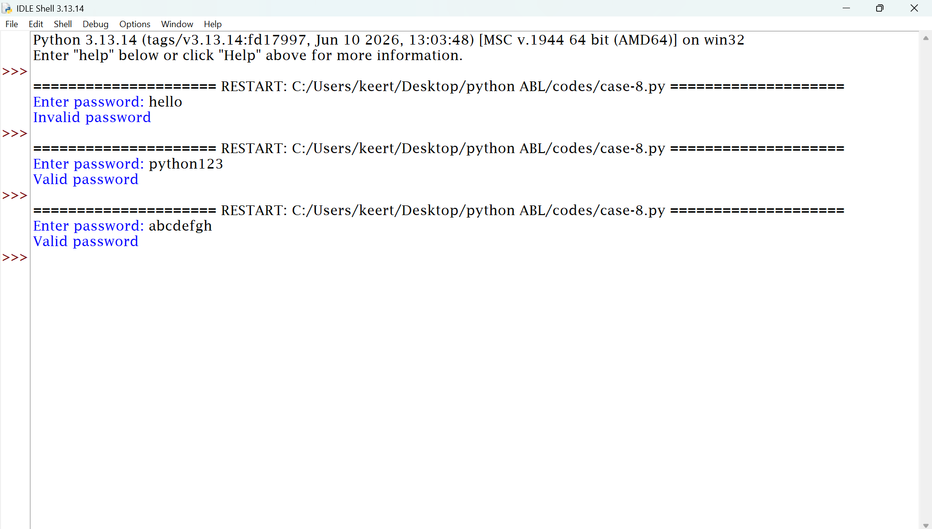

10. Conclusion
The program checks password length and determines whether it satisfies the minimum length requirement.

CASE STUDY 31: String-Based Examination Answer Evaluation
1. Problem Statement
To compare a student's answer with a correct answer and determine whether the answer is correct or incorrect.
2. Objectives
- To accept the correct answer.
- To accept the student's answer.
- To compare the two answers.
- To display the result.
3. Assumptions
- The program evaluates one question.
- The student receives one mark for a correct answer.
- An incorrect answer receives zero marks.
- Answers are compared without considering uppercase or lowercase differences.
4. Algorithm
- Start.
- Input the correct answer.
- Input the student's answer.
- Convert both answers to lowercase.
- Compare the answers.
- If they match, award one mark.
- Otherwise, award zero marks.
- Display the result.
- Stop.

5.Flowchart
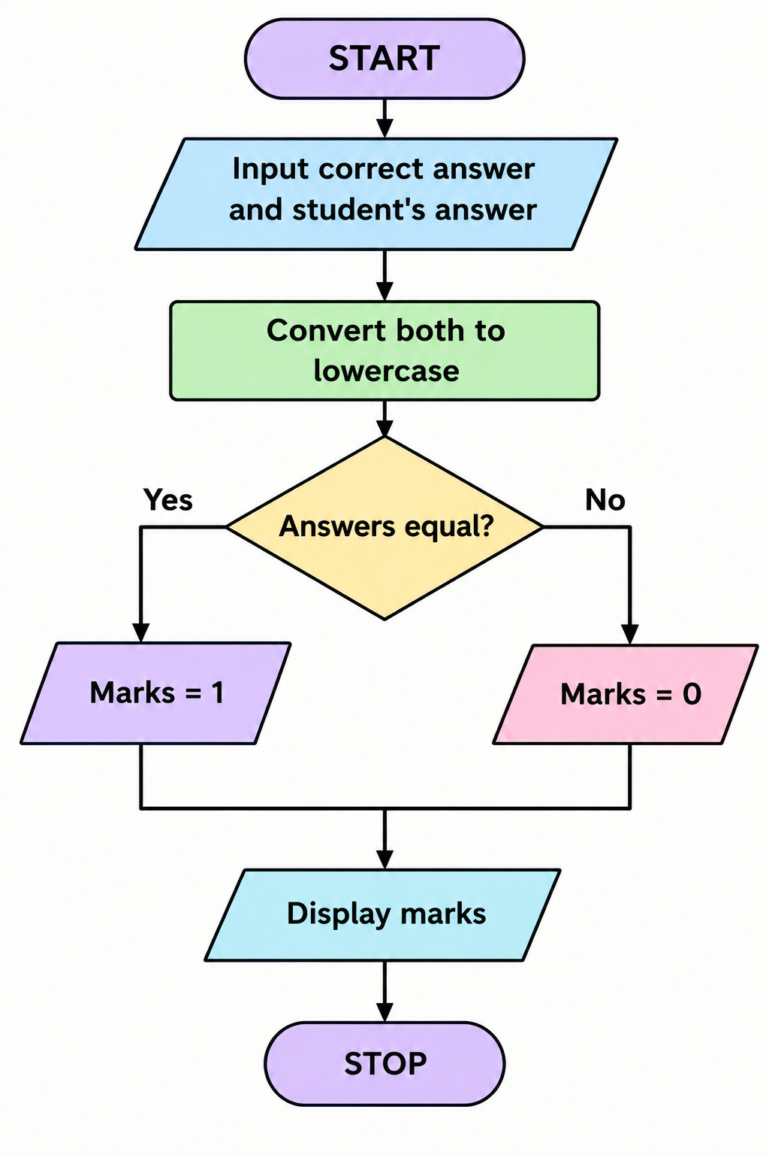

6. Pseudocode
START
INPUT correct_answer
INPUT student_answer
Convert both answers to lowercase
IF correct_answer == student_answer
marks = 1
ELSE
marks = 0
PRINT marks
STOP

7. Python Source Code
correct = input("Enter correct answer: ").lower()
answer = input("Enter your answer: ").lower()
if answer == correct:
print("Correct answer")
print("Marks: 1")
else:
print("Wrong answer")
print("Marks: 0")

8. Test Cases
Correct Answer | Student Answer | Expected Result
python | Python | 1 mark
python | Java | 0 marks
Python | Python | 1 mark
9.Screenshots
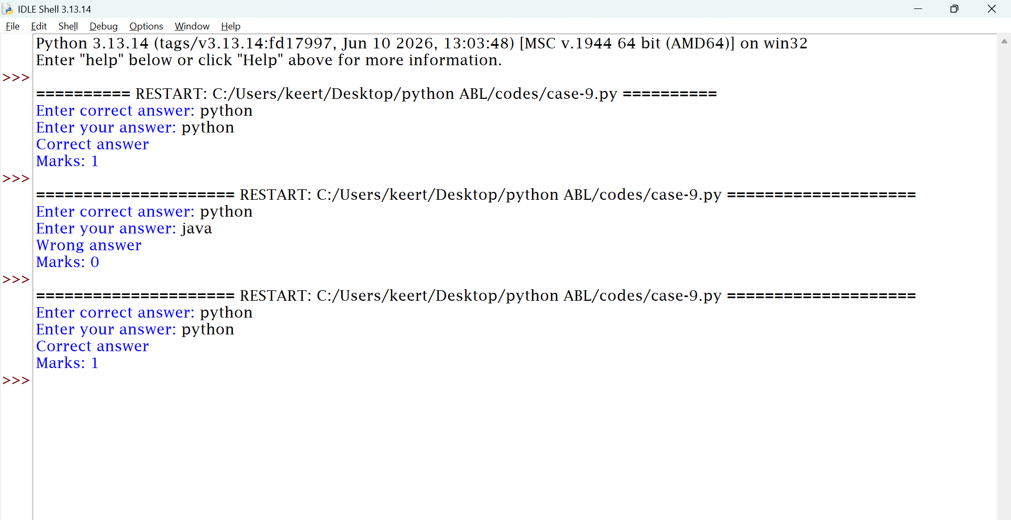

10. Conclusion
The program compares the student's answer with the correct answer and awards marks automatically.

CASE STUDY 53: Food Waste Monitoring System

1. Problem Statement
To calculate the number of leftover meals and determine the percentage of food wasted in a college canteen.
2. Objectives
- To calculate leftover meals.
- To calculate the food-waste percentage.
- To determine whether food waste exceeds a specified limit.
3. Assumptions
- The user enters the number of meals prepared and served.
- Prepared meals must be greater than zero.
- Served meals cannot exceed prepared meals.
- The acceptable food-waste limit is 20% for this example.
4. Algorithm
- Start.
- Input the number of meals prepared.
- Input the number of meals served.
- Calculate leftover meals.
- Calculate the waste percentage.
- If waste is greater than 20%, display high food waste.
- Otherwise, display acceptable food waste.
- Stop.

5. Flowchart

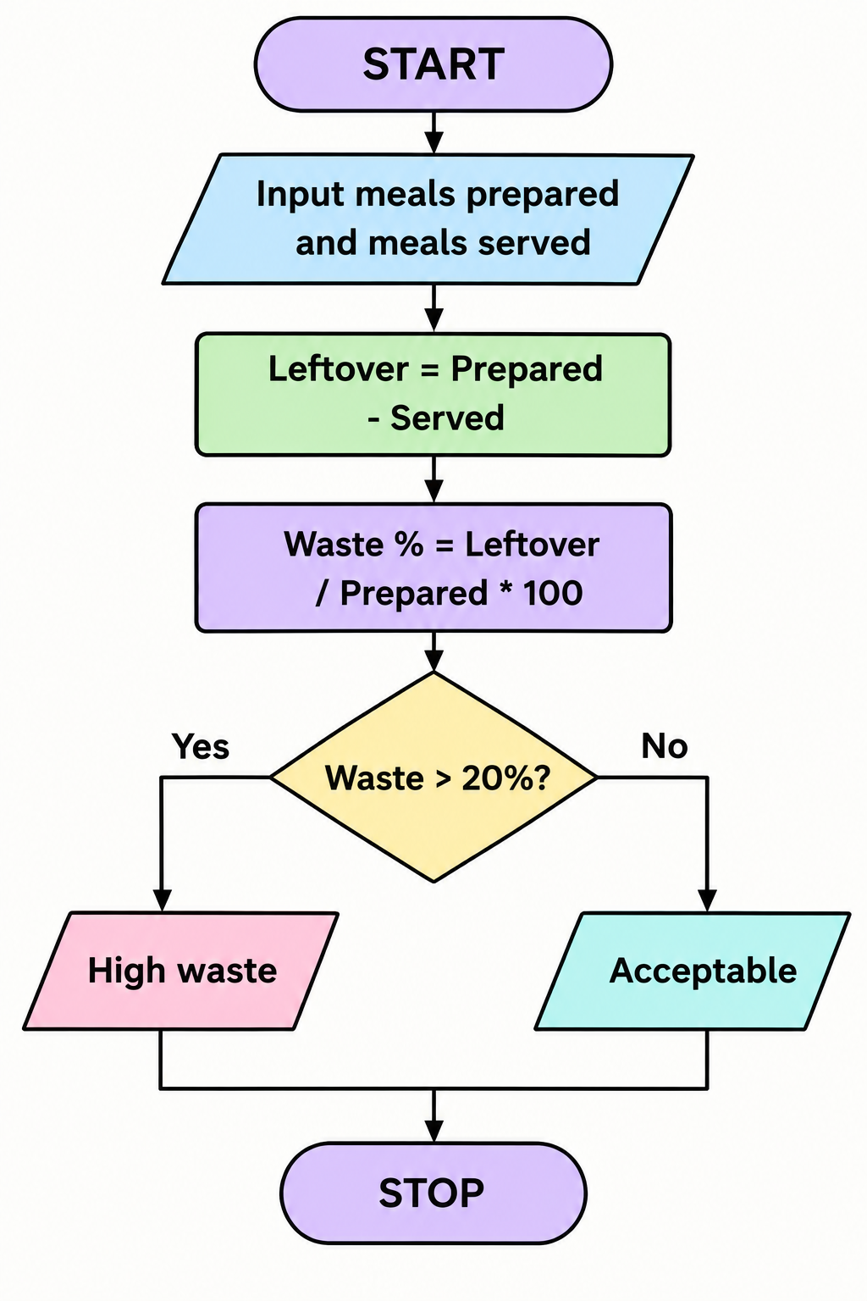

6. Pseudocode
START
INPUT prepared
INPUT served
leftover = prepared - served
percentage = leftover / prepared * 100
IF percentage > 20
PRINT high food waste
ELSE
PRINT acceptable food waste
PRINT leftover
PRINT percentage
STOP

7. Python Source Code
prepared = int(input("Enter meals prepared: "))
served = int(input("Enter meals served: "))
leftover = prepared - served
percentage = leftover / prepared * 100
print("Leftover meals:", leftover)
print("Waste percentage:", percentage, "%")
if percentage > 20:
print("High food waste")
else:
print("Acceptable food waste")

8.Test Cases
Prepared |  | Served | Leftover | Expected Result
100 |  | 70 | 30 | High food waste
100 |  | 90 | 10 | Acceptable food waste
100 |  | 80 | 20 | Acceptable food waste

9.Screenshots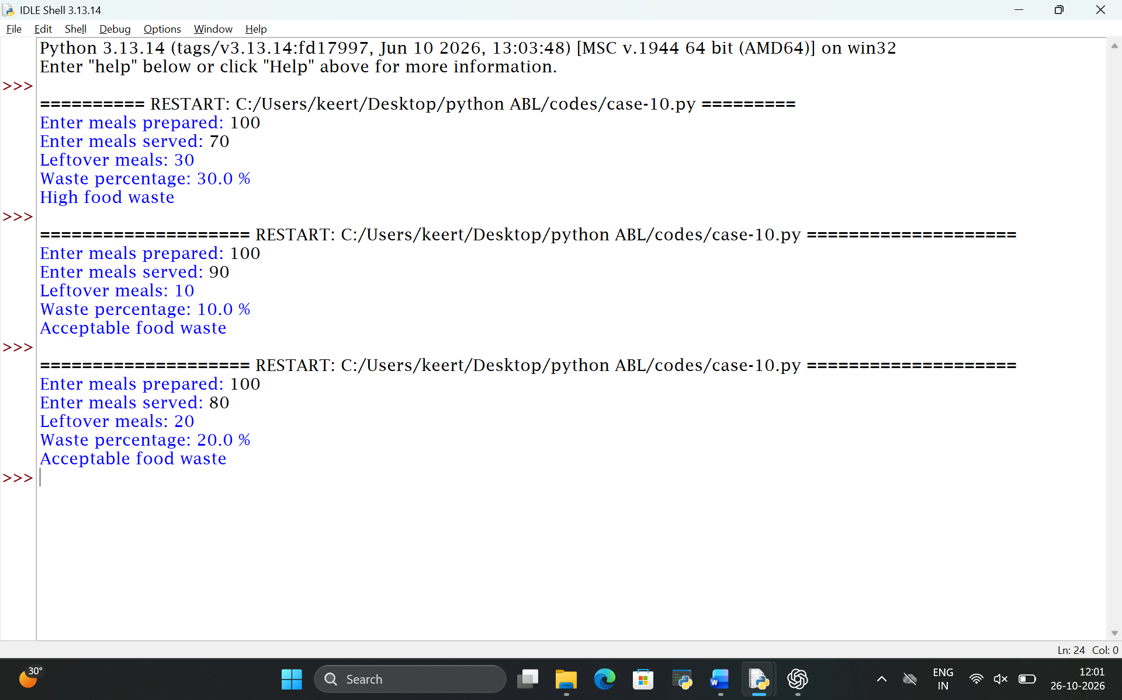

10. Conclusion
The program calculates leftover meals and identifies whether food waste exceeds the acceptable limit.

